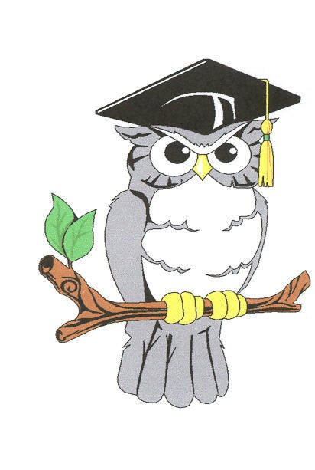BE WATER WISE
BE A S.T.A.T.E. GRADUATE!
WHEN: MAY 11, 2018
WHERE: Oxbow Meadows Environmental Learning Center
TIME: 10:00am – 2:00pm
Prizes Include:
1st Place - $750 2nd Place - $500 3rd Place - $300
Honorable Mention - $200

Columbus Water Works, Oxbow Meadows Environmental Learning Center, Keep Columbus Beautiful Commission and the Chattahoochee RiverWarden developed an environmental awareness program aimed at students in grades 6 through 12. The program is titled S.T.A.T.E University (Students Taking Action Towards Environment), and is in the form of a competition by school teams. The best team projects will be presented at a Workshop at Oxbow Meadows in the spring. There will be a 1st, 2nd, 3rd, and honorable mentioned prizes awarded.
The focus of the S.T.A.T.E. University program is:
W = Watershed + Wetlands + Water Quality + Wildlife
+ Water Conservation

The theme for the competition is: Water Conservation

The objective of the program is for the teams to develop a project demonstrating the concept of a watershed approach and how that affects Water Conservation of our region and to use their project in some public outreach manner.

Rules of the competition:
- Projects must show the importance water conservation to the region. This could include the importance to humans or wildlife, or both, and may consider environmental and economic impacts..
- Projects must be used by the team in some form of outreach or public education as presented to the judges, and need to include a plan to raise public awareness of the issue.
- The project should propose a solution to the problem identified.
- The project should be designed to be displayed in a space 4’ by 7’, and each team must make a verbal presentation to the S.T.A.T.E. U judges and audience. The presentations should be a maximum of 3 minutes along with 2 minutes of questions from the judges and audience. We encourage that this be a student run project.

ENTRY FORM

BE A S.T.A.T.E. GRADUATE

W = Watershed + Wetlands + Water Quality + Wildlife
+ Water Conservation

The theme of this year’s competition is: Water Conservation

All participates will receive a S.T.A.T.E. University t-shirt and a “certificate”.

To enter, complete this form and return by April 6, 2018 to:

Gwen Russell
Columbus Water
P. O. Box 1600
Columbus, GA 31902

If you have any questions, please call Gwen Russell at (706) 649-3454 or fax at
(706) 649-3300. You may also e-mail your Entry Form to: grussell@cwwga.org
______________________________________________________________________________

ONE TEAM PER SCHOOL

School Name:

Participating Teacher:
Email Address:
Telephone Number:

Participating Students (Four students and one alternate)

________________________ _______________________

________________________ _______________________

Alternate: ___________________________

Subject and name of project:

______________________________________________________________________________

______________________________________________________________________________

______________________________________________________________________________

