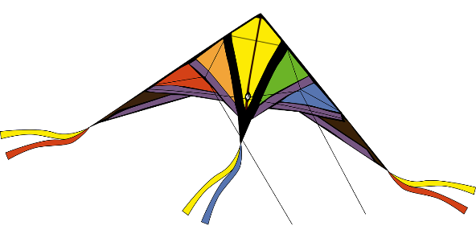
The 1st Annual Kite Festival at Oxbow Meadows

Kite Making Contest

February 24, 2018
10am-2pm

Oxbow Meadows is proud to host the 1st Annual Kite Festival and would like to invite you to participate in the Kite Making Contest. Kited entered into the contest must by handmade, no store bought kites are eligible. The contest is open to anyone for either the Youth Division (12 and under) or the Adult Division (13 and up). Kite makers may register the day of the Kite Festival and have their kites displayed during the event. All contestants must be registered by 12pm and the winners will be announced at 1:30pm.

The Kite Criteria:

All competing kites must fly:
- On a minimum of a 10 foot line
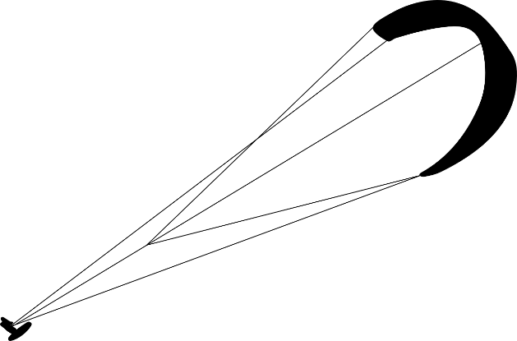
- For a minimum of 30 seconds

Funniest
- The kite with the best sense of humor

Biggest
- Total surface area, not including tail

Smallest
- Total surface area, not including tail

Longest Tail
- Total length of tail

Most Creative
- Kite design, flight pattern, or idea

Oldest and Youngest Flier
- The oldest and youngest contestant will be awarded, contestants must fly kits unassisted.

Additional Rules
- Only one kite entry per person
- Judges decision is final
- Oxbow Meadows is not responsible for loss or damage to any entries
- Registration is from 10am-12pm. The kits completion is from 12-1:30 and the winners announced at 1:30.

_ _ _ _ _ _ _ _ _ _ _ _ _ _ _ _ _ _ _ _ _ _ _ _ _ _ _ _ _ _ _ _ _ _ _ _ _ _ _ _ _

Kite Festival Entry Form

Name of contestant: _____________________________________________

Name of guardian: ______________________________________________

Email Address: ________________________________________________

Category (Circle one):

Funniest Longest Tail Oldest

Biggest Creative Youngest

Smallest

Age Group (Circle one):

Youth (12 and Under)

Adult (12 and Up)

